Where to Save on the Student Device
Students have several locations that they can save files when working on their BCPS device. The best place to save files in their Office 365 OneDrive. This is a cloud-based location that can be accessed from any device with an internet connection. The OneDrive Sync Client allows users to save files if they are connected to the web or not.
There are some options for saving to the local hard drive if needed.
OneDrive First Run
- Make sure that Office has been launched, open Word, and that the Accept and start button has been clicked.
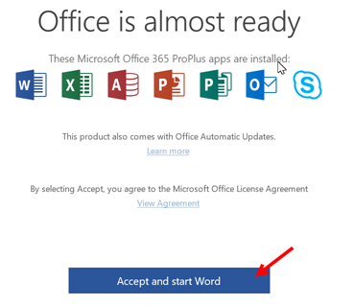
- Click on the OneDrive clouds icon in the system tray.
- Click the Sign In button.
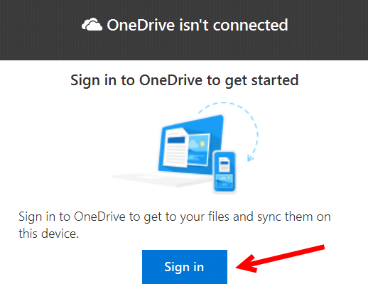
- Enter FULL user name WITH the @bcps.org where it says Enter your email address. Do NOT use a private email account. (Graphic on next page.)
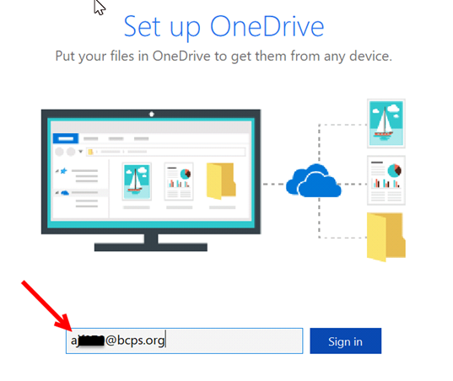
- Click Next.
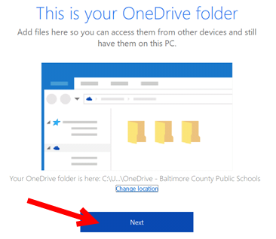
- Click the right arrow to advance through the intro screens.
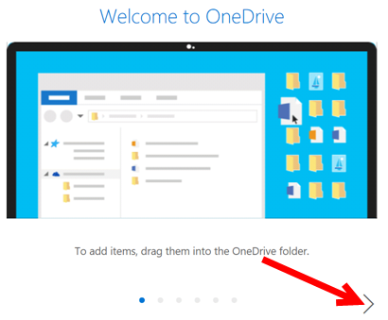
- Click Open my OneDrive folder button.
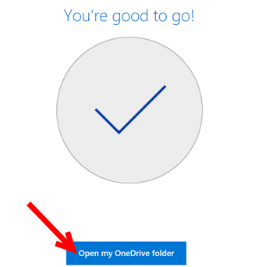
- The folder will open and the OneDrive cloud icon will turn blue.
OneDrive Baltimore County Public Schools is now available in the File Explorer.
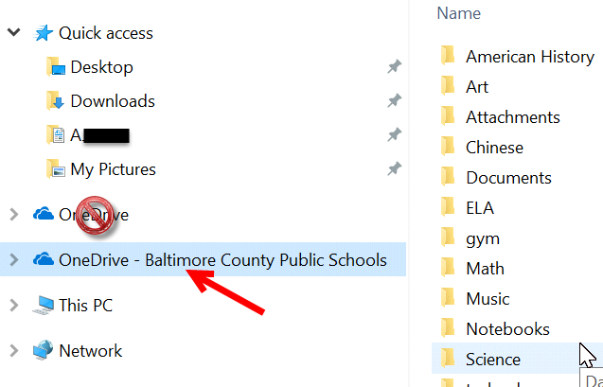
Save to OneDrive
- From the save dialog box select OneDrive – Baltimore County Public Schools and save the file as normal.
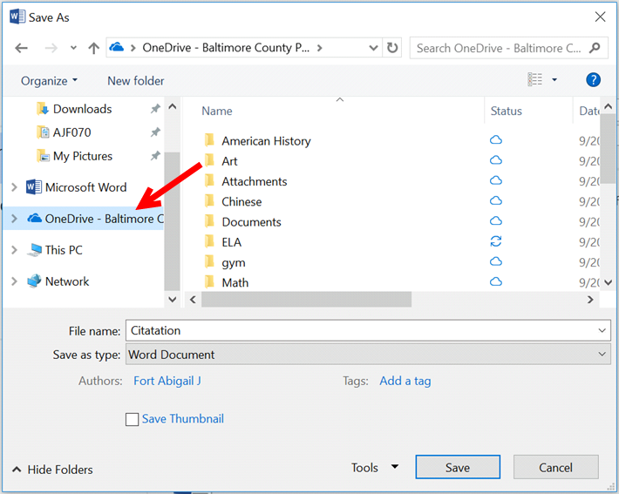
- This location can be used even if the device is off line. The file is stored locally and then uploaded to the cloud location when back on the network.

Local Saving Option
If for some reason the OneDrive – Baltimore County Public Schools location is not available there is a local save area that students can access on their devices.
From the save dialog box click on Downloads that will be under Quick access*. Saving files in this location is allowed.
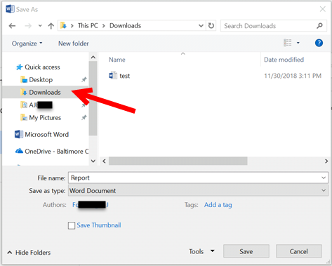
*If Quick access does not list Downloads go to This PC and then scroll to Downloads.
