2021

FAMILY RESOURCE ACADEMY

ON DEMAND

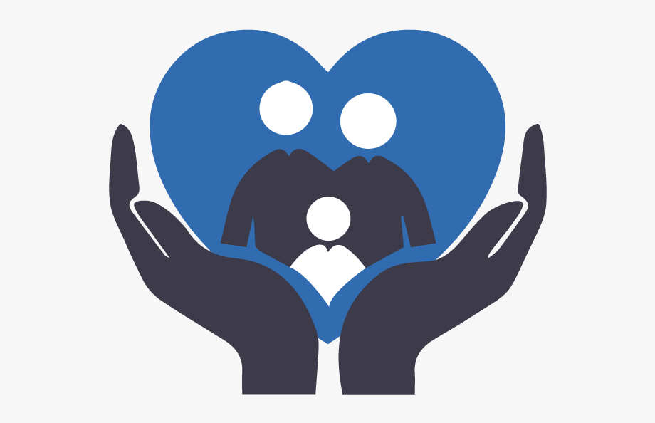
A Personal Story of Trauma and Recovery
A former criminal defense attorney and juvenile advocate shares her personal story.

The workshops are FREE!
Registration is required.

FamilyNavigator@cc-md.org 667-600-3074
*Upon registration, a link will be sent to you

Emotion Regulation
Caregiving is an emotional journey.
Learn ways to cope with difficult emotions.

In partnership with professional child development specialists and veteran family members, the Family Resource Academy has designed a series of FREE On Demand workshops just for you. The Family Resource Academy may be just what you need for support, strength, and understanding that can enhance your ability to parent a child with intensive behavioral health needs and to understand and reduce the effects of Adverse Childhood Experiences.

